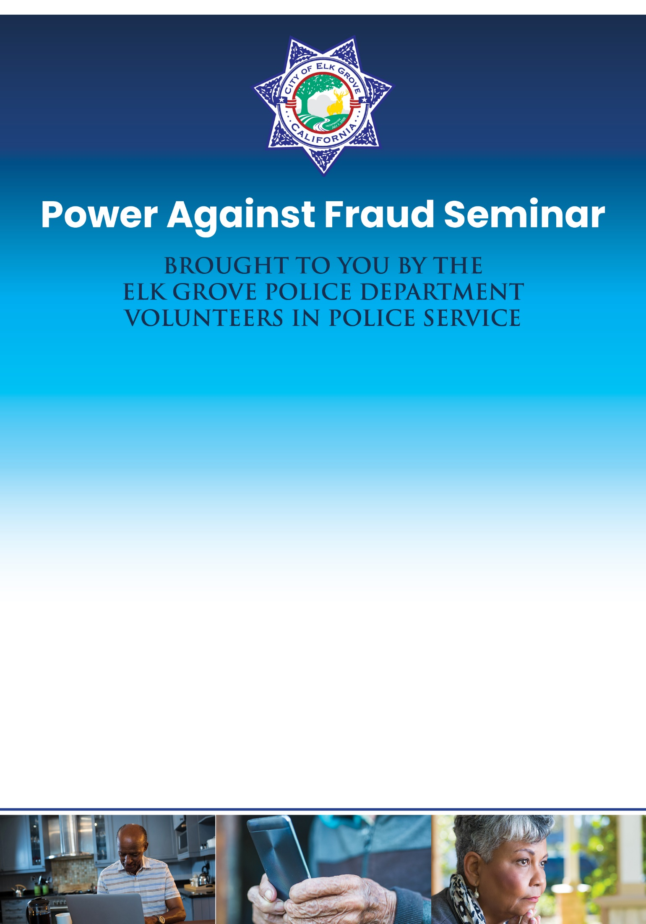
Wednesday, July 10, 2024
Elk Grove Veterans Memorial Hall
District 56, 8230 Civic Center Drive
6:00 PM – 7:30 PM
Sponsored by
American Legion Post 55 Laguna-Elk Grove
Elk Grove PD wants our citizens to be prepared for potential fraud and economic crimes. Older adults are seen as easy targets of crimes such as identity theft, telemarketing and internet fraud, impersonation scams, door-to-door scams, and street cons.

At this ALL-NEW fraud prevention seminar, you will learn simple yet effective self-defense strategies to increase your POWER AGAINST FRAUD. Don’t let yourself fall victim to fraud. Take advantage of the opportunity to harden yourself as a target by attending this on-site seminar.

